**MIDDLE EAST TECHNICAL UNIVERSITY**

**DEPARTMENT OF ELECTRICAL & ELECTRONICS ENGINEERING**



**TROY TECH**

**WEEKLY REPORT #6**

**23.03.2019-29.03.2019**

**Section :** 7

**Studio Coordinator:** Mustafa Mert ANKARALI

**Partners :**

Hasan ÖZKARA - 2031888

Kağan ÖZASLAN - 2031854

Caner POTUR - 2031250

Mustafa Ercan OKATAN - 2031193

Mert KAYIŞ – 2030997

**Progresses for Previous Week:**

→ We designed, bought and implemented the body of the robot:

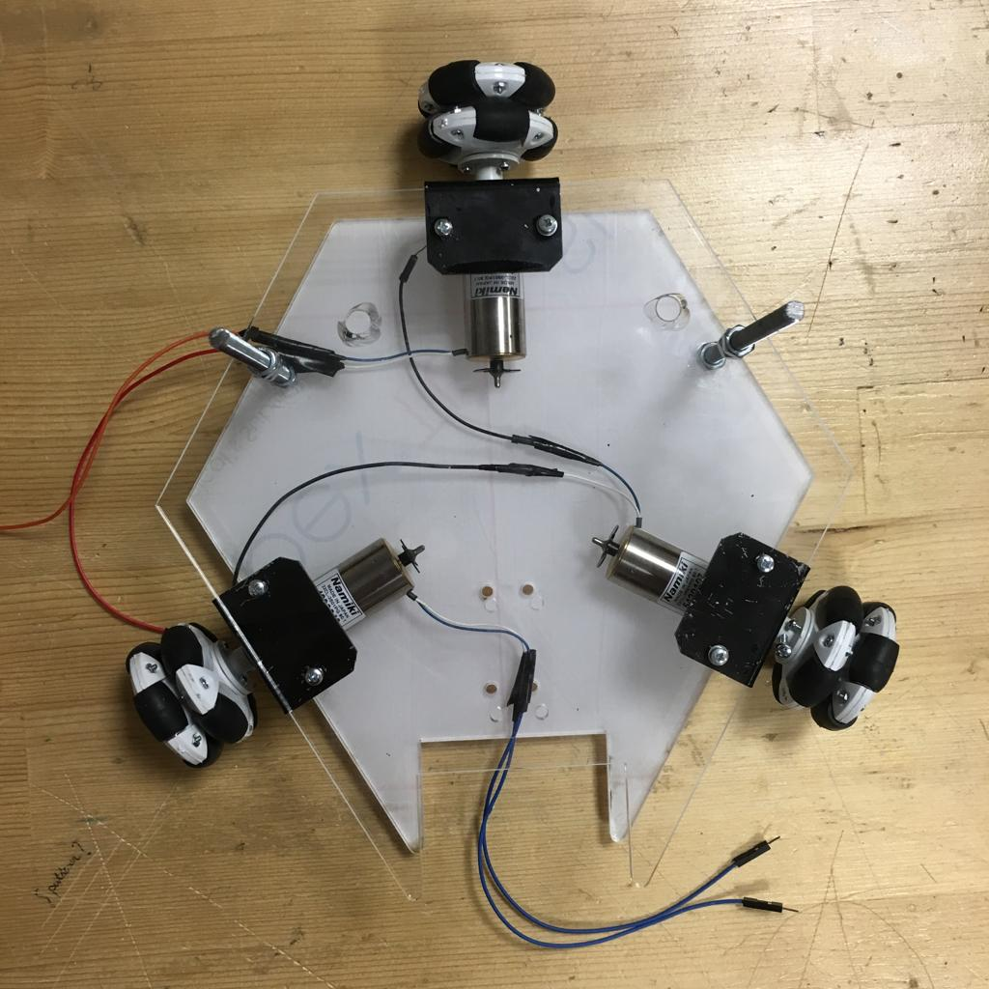

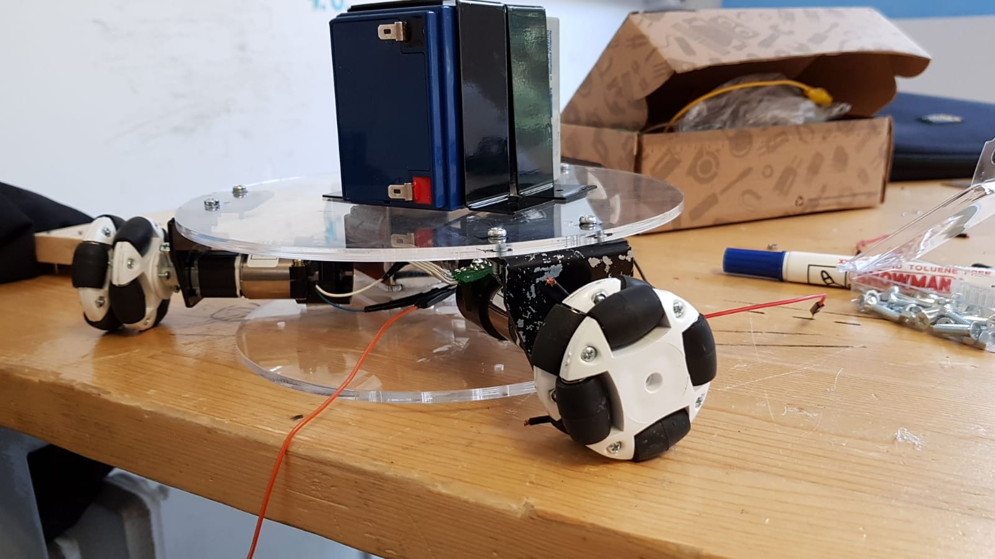

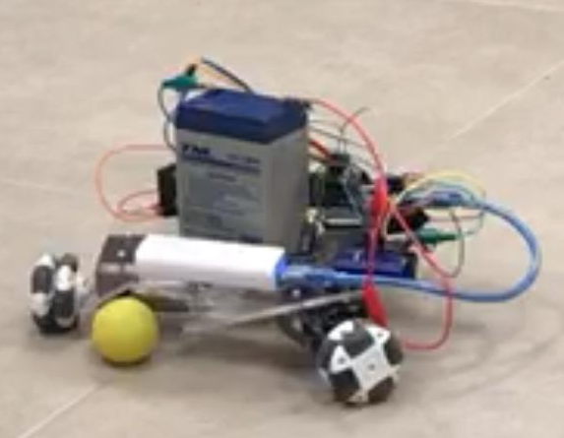

→ We tried the new capacitors and created the shooting system. Also, we tried with Arduino Mega and it worked properly.

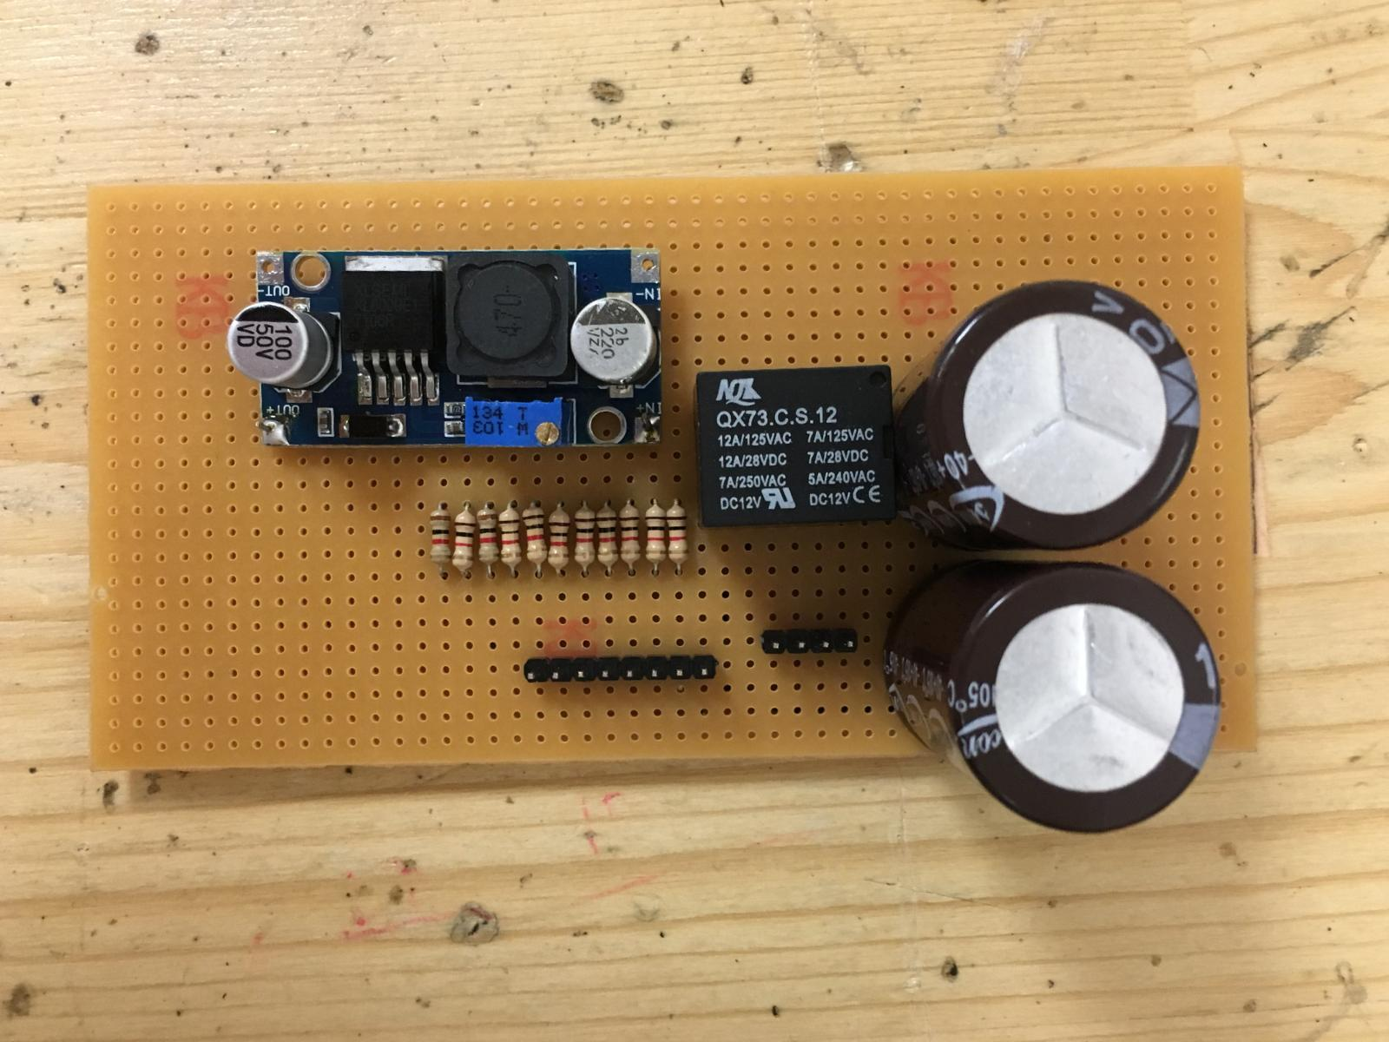

→ We implemented the motor drive system with omni-wheels and it worked properly.

**Plans for Next Week:**

- Completing the implementation of the robot

-Video transmission optimization(i.e. camera position)

-Shooting system optimization

-Command Transmission optimization(i.e. adding gears)

- Overall system testing